A An Truong Primary School.  Full name: Trần Hoàng Thái  Class: 4/1 | THE FRIST TERM TEST FOR GRADE 4  School year: 2025-2026  Time allowed: 30 minutes

READING ( 2,5 mark)
TASK 1. Look and tick ☑ or cross 🗵 (1.25 marks)
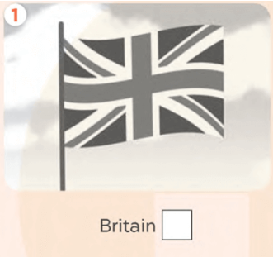 | 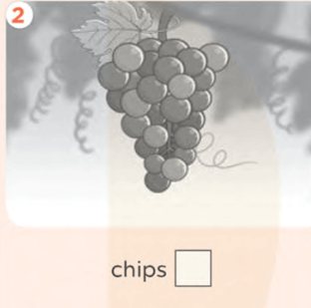 |  | 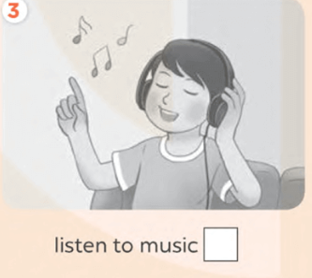
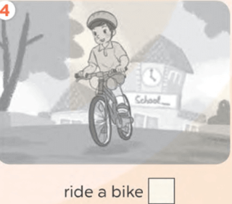 |  | 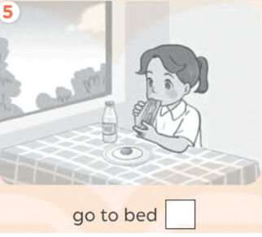

TASK 2. Read and circle. (1.25 marks)
We have a lot of fun at school. In our English lessons, we (1) __________ to English songs. We sing and chant. We (2) _______________ board games to learn English. (3)_____________ do projects together at the end of each unit. (4)_______________, it was sunny. We (5) ____________ in the school garden. There were many flowers and birds. We were happy.
1. | a. listen | b. write | c. speak
2. | a. read | b. play | c. sing
3. | a. They | b. You | c. We
4. | a. Yesterday | b. Now | c. Weekend
5. | a. are | b. was | c. were

WRITING (2,5 marks)
I. Look and write. (2,5 marks)
  V………………….. |   J……………. | 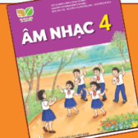  M……………… |   J……….


c………………………….

A An Truong Primary School.  Full name: Nguyễn Ngọc Như Ý  Class: 4/2 | THE FRIST TERM TEST FOR GRADE 4  School year: 2025-2026  Time allowed: 30 minutes

READING ( 2,5 mark)
TASK 1. Look and tick ☑ or cross 🗵 (1.25 marks)

TASK 2. Read and circle. (1.25 marks)
We have a lot of fun at school. In our English lessons, we (1) __________ to English songs. We sing and chant. We (2) _______________ board games to learn English. (3)_____________ do projects together at the end of each unit. (4)_______________, it was sunny. We (5) ____________ in the school garden. There were many flowers and birds. We were happy.
1. | a. listen | b. write | c. speak
2. | a. read | b. play | c. sing
3. | a. They | b. You | c. We
4. | a. Yesterday | b. Now | c. Weekend
5. | a. are | b. was | c. were

WRITING (2,5 marks)
I. Look and write. (2,5 marks)
V………………….. | J……………. | M……………… | J……….

c………………………….

